WEEK 5:
SYSTEM INTEGRATION AND PROTOTYPE PREPARATION

Balisacan, Mark Justin F.
Binuya, John Lloyd A.
Reyes, Allysa B.

WEEK 5: SYSTEM INTEGRATION AND PROTOTYPE PREPARATION

I. INTENDED LEARNING OUTCOME (ILO)
At the end of this laboratory activity, students should be able to:
Integrate completed system modules into a functional Alpha Version, conduct preliminary functionality checking, document integration results, and prepare professional prototype presentation materials for stakeholder evaluation.

II. PERFORMANCE TASK
By Week 5, the individual modules developed during Weeks 3 and 4 should be integrated into a single working system. Before presenting the prototype to stakeholders in Week 6, your team must verify module interactions, identify and resolve integration issues, and prepare prototype presentation materials.
The resulting Alpha Version should demonstrate the major functionalities of the system and provide evidence that the project is progressing toward deployment readiness.

III. WEEK 5 ACTIVITIES
Activity 1 – Module Integration Planning
Activity 2 – Full System Integration
Activity 3 – Preliminary Functionality Checking
Activity 4 – Alpha Version Validation
Activity 5 – Prototype Presentation Preparation
Activity 6 – System Integration Documentation
Activity 7 – Adviser Validation

ACTIVITY 1
MODULE INTEGRATION PLANNING

Purpose
To identify all modules that will be combined into the Alpha Version and verify their readiness for integration.
Procedure
- Review all completed modules from Weeks 3 and 4.
- Verify module completion status.
- Identify dependencies among modules.
- Establish integration sequence.
- Complete Form 1.

FORM 1
MODULE INTEGRATION PLAN
Directions
List all modules to be integrated into the Alpha Version.
Module | Completion Status | Dependency | Integration Sequence
Authentication and User Registration Module | Complete | Database, OTP service | 1
User Verification Module | Complete | Authentication, Database, Camera | 2
User and Role Management Module | Complete | Authentication, Database | 3
Resident Report Submission Module | Complete | Authentication, GPS, Camera, Database | 4
Report Validation Module | Complete | Report Submission, User Management | 5
Branch Admin Lineman Assignment Module | Complete | Report Validation, Lineman Accounts, Lineman Availability | 6
Lineman Task Management Module | Complete | Lineman Assignment, Database | 7
Report Status Tracking Module | Complete | Report Submission, Task Management | 8
GPS and Map Visualization Module | Complete | GPS, Report Database, Mapping Service | 9
Notification Module | In Progress | Report Status, Barangay Data, Notification Service | 10
Power Advisory Module | Complete | Database, Barangay Data, User Management | 11
Descriptive Analytics Module | Complete | Report Database, Status Tracking | 12
Report Generation and Printing Module | In Progress | Report Database, Analytics | 13

Integration Readiness Checklist
☑Database Ready
☑ Authentication Ready
☑ Core Functionalities Ready
☑ User Interfaces Ready
☑ Repository Updated

Prepared by: Allysa B. Reyes
Group Leader

ACTIVITY 2
FULL SYSTEM INTEGRATION

Purpose
To combine all completed modules into a single working system.
Procedure
- Integrate front-end modules.
- Integrate back-end services.
- Connect database operations.
- Verify communication among modules.
- Complete Form 2.

FORM 2
SYSTEM INTEGRATION CHECKLIST
Directions
Indicate the integration status of each component.
Component | Status | Remarks
User Interface Modules | Integrated | All major user interface modules are integrated and functional.
Authentication Module | Integrated | User registration, login, and authentication features are integrated.
Database Module | Integrated | Database operations for storing and retrieving system data are integrated.
Reporting Module | Integrated | Report submission, management, and status tracking features are integrated.
Notification Module | In Progress | Notification features are currently being developed and integrated.

Integration Verification
Verification Item | Result
Data Flow Verified | Pass
Module Communication Verified | Pass
Database Transactions Verified | Pass
User Access Verified | Pass

Required Evidence

MOBILE
□ Integration Screenshots
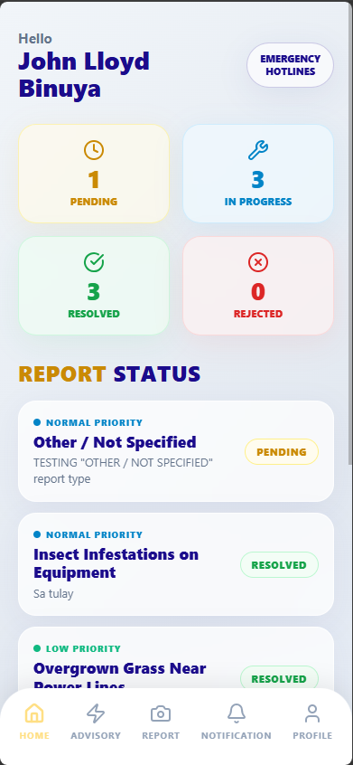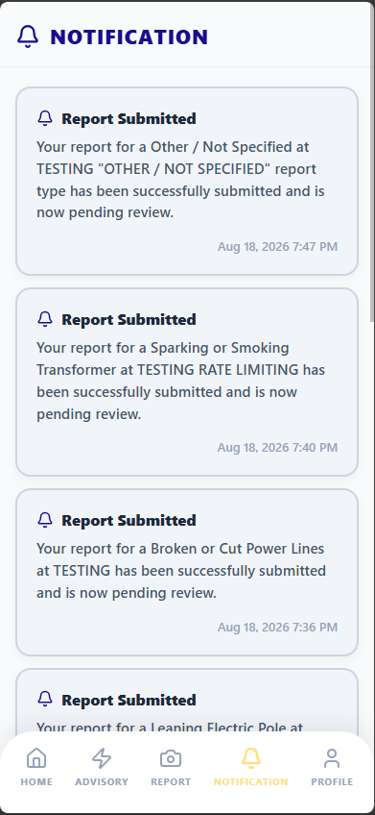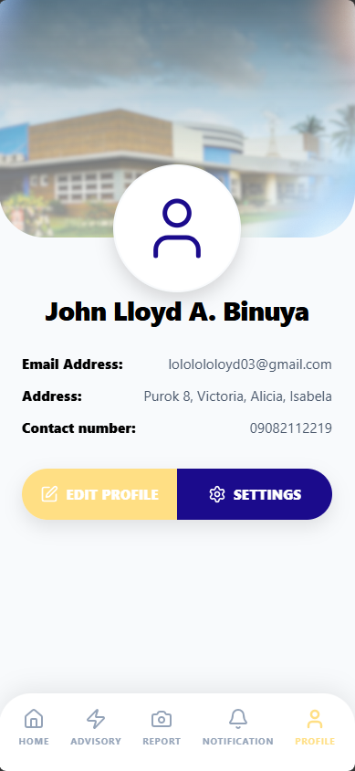

□ Running System Screenshot | □ Repository Commit Evidence  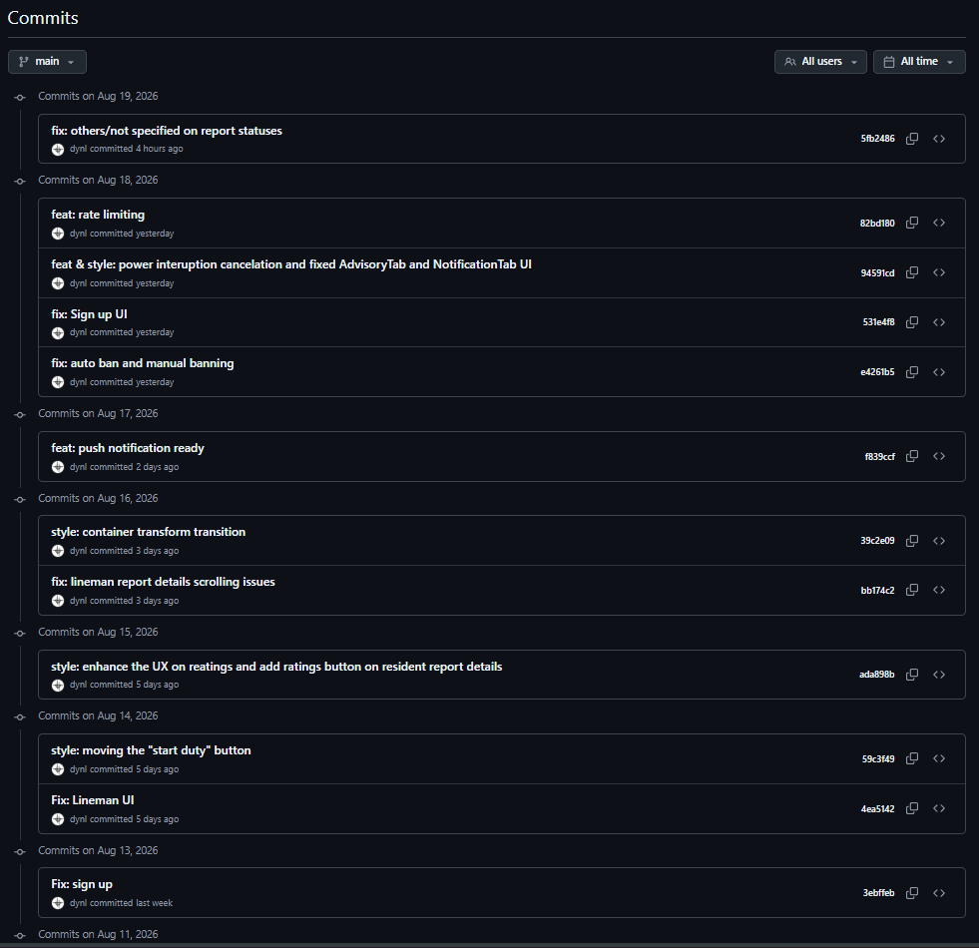
ACTIVITY 3
PRELIMINARY FUNCTIONALITY CHECKING

Purpose
To verify that major system functions operate correctly before prototype presentation.
Procedure
- Execute major user transactions.
- Verify expected outputs.
- Identify integration errors.
- Record corrective actions.
- Complete Form 3.

FORM 3
PRELIMINARY FUNCTIONALITY TEST REPORT

Directions
Test the major functionalities of the system.
Functionality | Expected Result | Actual Result | Status
User Login |  | User successfully logged in and was redirected to the appropriate dashboard. | Pass
  The user can log in using valid credentials and is redirected to the appropriate dashboard.
Data Entry | The system accepts and saves valid user inputs correctly. | The system accepts and saves valid user inputs correctly. | Pass
Data Processing |  |  | Pass
  The system correctly processes submitted data according to the required system workflow.
  The system correctly processes submitted data according to the required system workflow.
Data Retrieval |  | Data was successfully retrieved and displayed correctly. | Pass
  The system retrieves and displays the requested data accurately.
Report Generation |  | Reports were successfully generated based on the recorded data. | Pass
  The system generates reports based on the available system data.

Issues Encountered
Issue | Severity | Corrective Action
UI is not responsive on mobile devices | Medium | Adjusted the responsive layout, sizing, spacing, and navigation to ensure the interface displays properly on different mobile screen sizes.
No cancel option for power interruption reports | Medium | Added a cancel option that allows users to cancel a pending power interruption report before it is processed.
No view details option for reports in the Admin Portal | High | Added a view details function that allows administrators to view the complete information, location, description, and other relevant details of a submitted report.
No printable reports | Medium | Added a printable report feature that allows administrators to generate and print report records for documentation and reference.

Tester Information
Conducted By: Dr. Desiray D. Nayga
Date: August 17, 2026

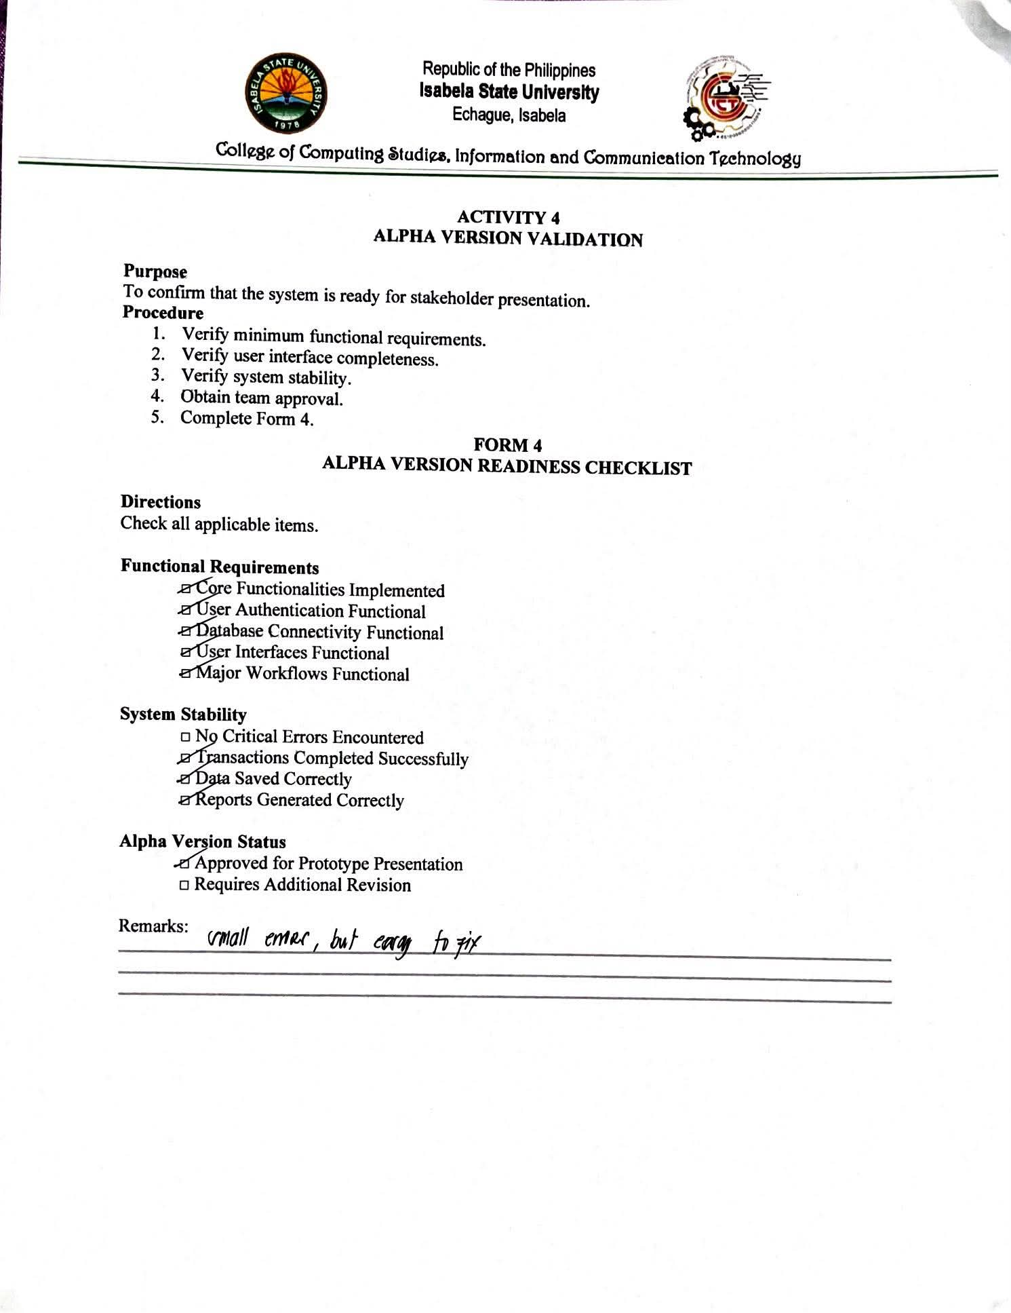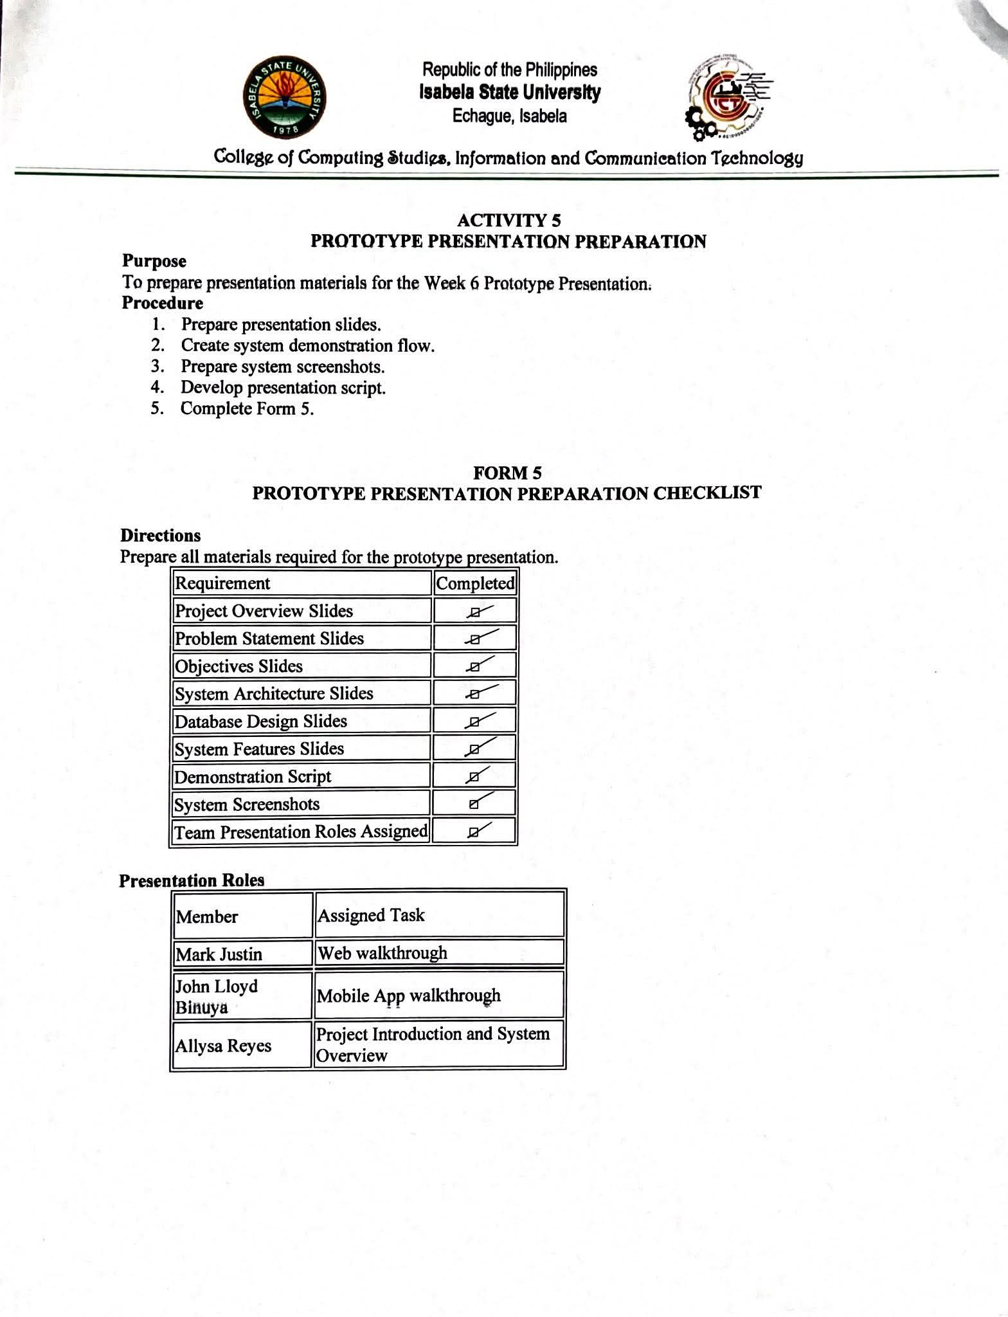
Required Evidence

□ Presentation Slides

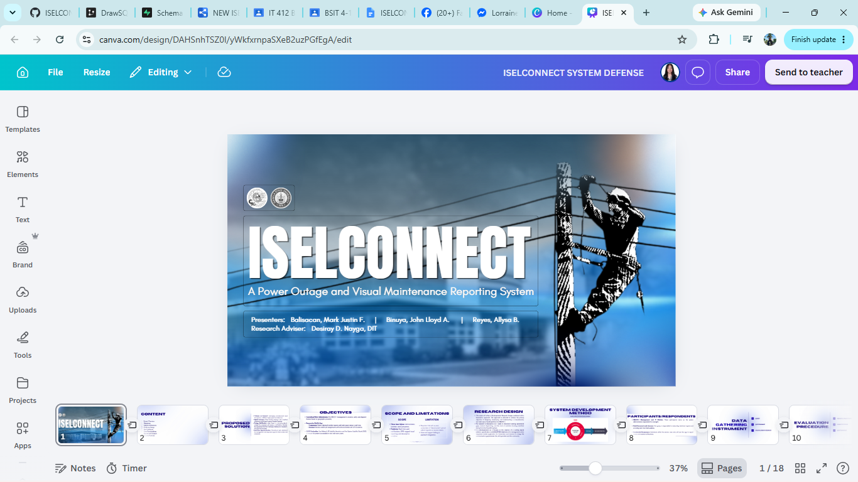
□ Demonstration Script

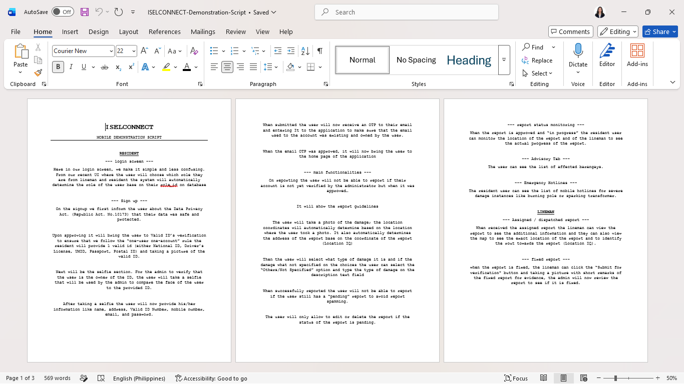

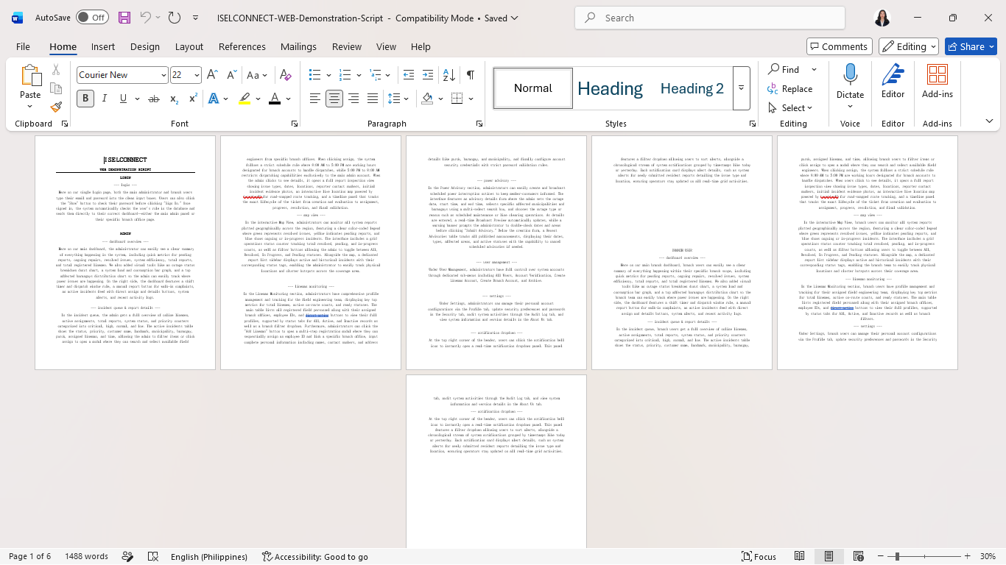
□ Prototype Screenshots
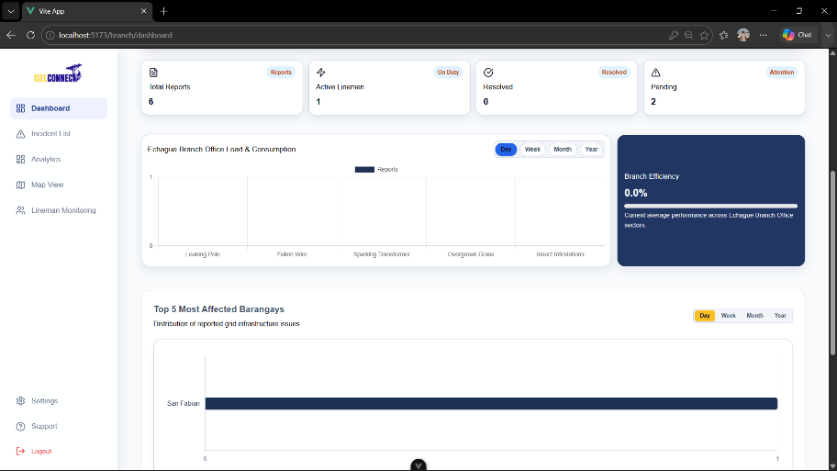

ACTIVITY 6
SYSTEM INTEGRATION REPORT

Purpose
To document integration activities and Alpha Version development.
Procedure
- Summarize completed integration activities.
- Document modules integrated.
- Record testing activities.
- Identify remaining enhancements.
- Complete Form 6.

FORM 6
SYSTEM INTEGRATION REPORT

Project Information
Project Title: ISELCONNECT: A Power Outage and Visual Maintenance Reporting System

Date Submitted:

Integrated Modules
Module | Status
User Interface Modules | Integrated
Authentication Module | Integrated
Database Module | Integrated
Reporting Module | Integrated
Notification Module | In Progress

Integration Summary
- The major system modules, including the user interface, authentication, database, and reporting modules, have been successfully integrated. The Notification Module is currently under development and will be integrated once its remaining functions are completed.

Preliminary Testing Summary
- Preliminary testing was conducted on the integrated modules to verify their basic functionality and interaction. Issues such as mobile responsiveness, report viewing, cancellation of power interruption reports, and printable reports were identified and addressed through corrective actions.

Enhancements Planned Before Week 6
- Complete the integration of the unfinished modules.
- Implement and refine printable report generation.
- Conduct additional functionality and compatibility testing.

Prepared by: Allysa Reyes

Group Leader

Reviewed by: Dr. Desiray D. Nayga

Project Adviser

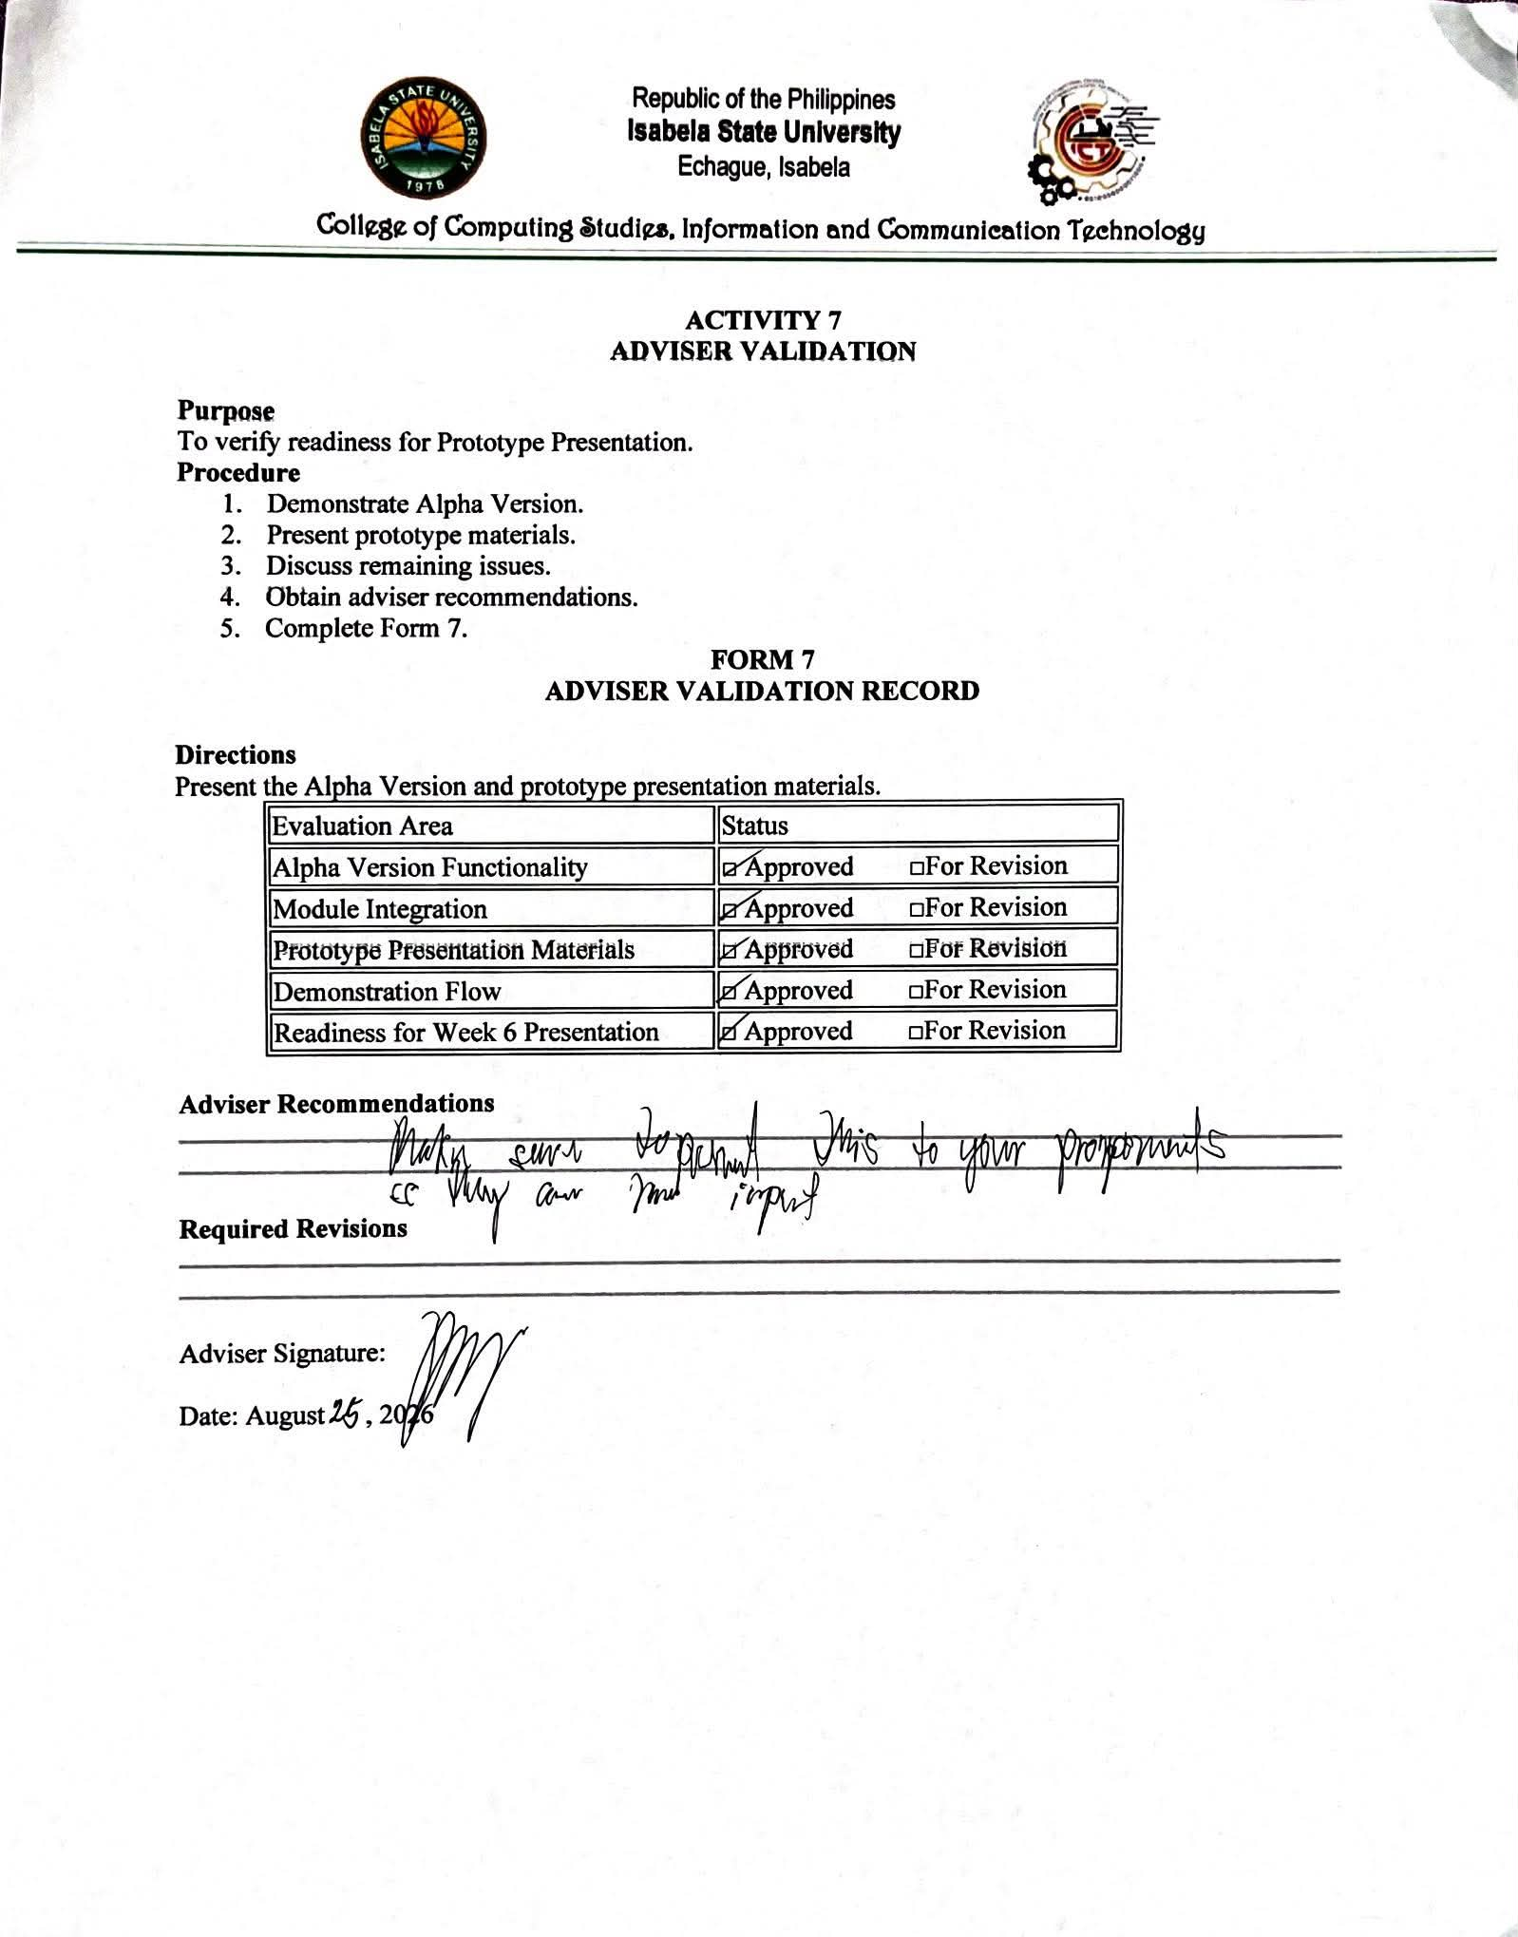

V. REQUIRED WEEK 5 SUBMISSION
- Form 1 – Module Integration Plan
- Form 2 – System Integration Checklist
- Form 3 – Preliminary Functionality Test Report
- Form 4 – Alpha Version Readiness Checklist
- Form 5 – Prototype Presentation Preparation Checklist
- Form 6 – System Integration Report
- Form 7 – Adviser Validation Record
- Alpha Version Source Code
- Prototype Presentation Slides
- Supporting Screenshots and Evidence

VI. WEEK 5 DELIVERABLES
✓ Alpha Version
✓ System Integration Report
✓ Prototype Presentation Materials
✓ Preliminary Functionality Test Results
✓ Updated Source Code Repository

VII. PERFORMANCE RUBRIC
Criteria | Weight
Module Integration Completeness | 25%
Alpha Version Functionality | 25%
Preliminary Functionality Checking | 15%
System Integration Report | 15%
Prototype Presentation Materials | 10%
Repository Updates and Documentation | 10%
Total | 100%

